**(Shokunbi samuel oluwasegun)**

**Windows 1,2 & 3 and Linux 1 fundamentals**

**Assessment Progress Report**

**As part of this assessment, I worked through both Windows and Linux foundational exercises and documented my progress with screenshots.**

**Windows Fundamentals Progress Report**

**Windows Fundamental 1**

**Windows Fundamental 1 introduced the basic structure and usage of the Windows operating system. The focus was on understanding the difference between Standard and Administrator user accounts, how permissions work, and why least privilege is important for security. I also learned how Control Panel and Settings are related, and how they link to other basic Windows tools used for system management.**

**This foundation helped me understand how users interact with the operating system and how improper permissions can affect system security.**

**Windows Fundamental 2**

**In Windows Fundamental 2, we focused more on system configuration and internal management tools. This included working with User Account Control (UAC) settings, monitoring system resources, and understanding how processes and performance are managed on a Windows machine.**

**We also explored the Windows Registry and learned its role in storing system and application configuration settings. This helped me understand how changes at the system level can affect stability, performance, and security.**

**Windows Fundamental 3**

**Windows Fundamental 3 covered built-in Windows security tools that come preinstalled with the operating system. These tools are designed to help protect devices against threats and enforce security policies.**

**Through this module, I gained a better understanding of how Windows provides native security features to protect systems, users, and data without the need for third-party tools.**

**Conclusion**

**Overall, these three fundamentals built a solid foundation in understanding Windows from usability, configuration, and security perspectives. They highlighted the importance of combining practical skills with a strong theoretical understanding to effectively manage and secure Windows systems**

**Linux Fundamentals**

Through the Linux exercises, I gained an understanding of why Linux is widely used today, particularly due to its flexibility and efficiency. I interacted with my first Linux machine and ran several basic Linux commands, which introduced me to working through the command line. I also learned how to navigate the filesystem and use commands such as find and grep to locate and filter data more efficiently. In addition, I was introduced to important shell operators, which helped me understand how to combine and enhance commands to work more effectively in a Linux environment.

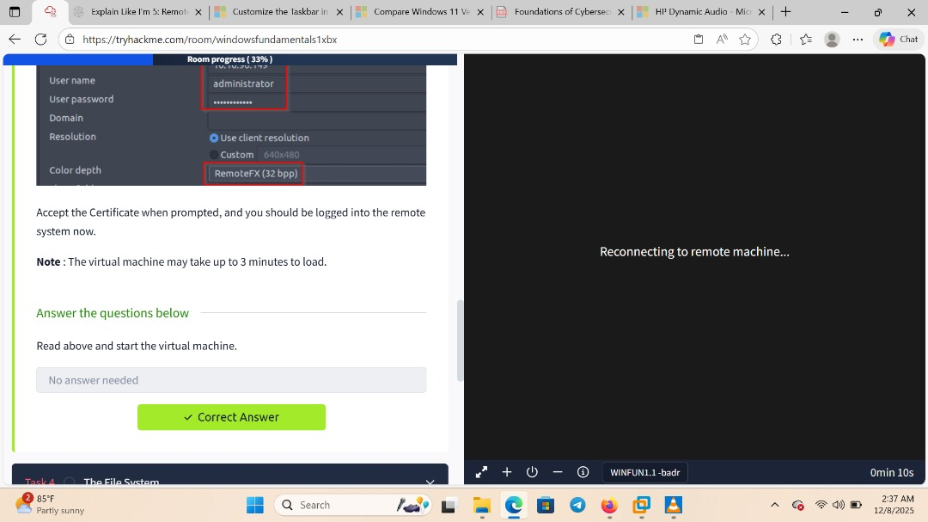

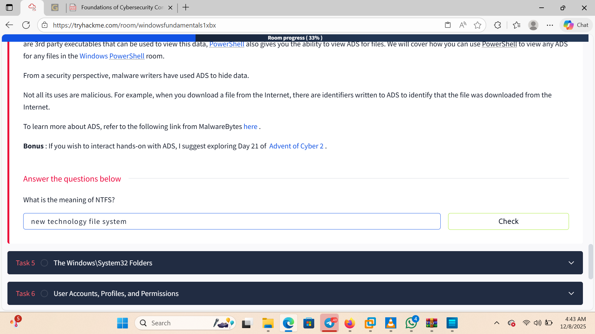

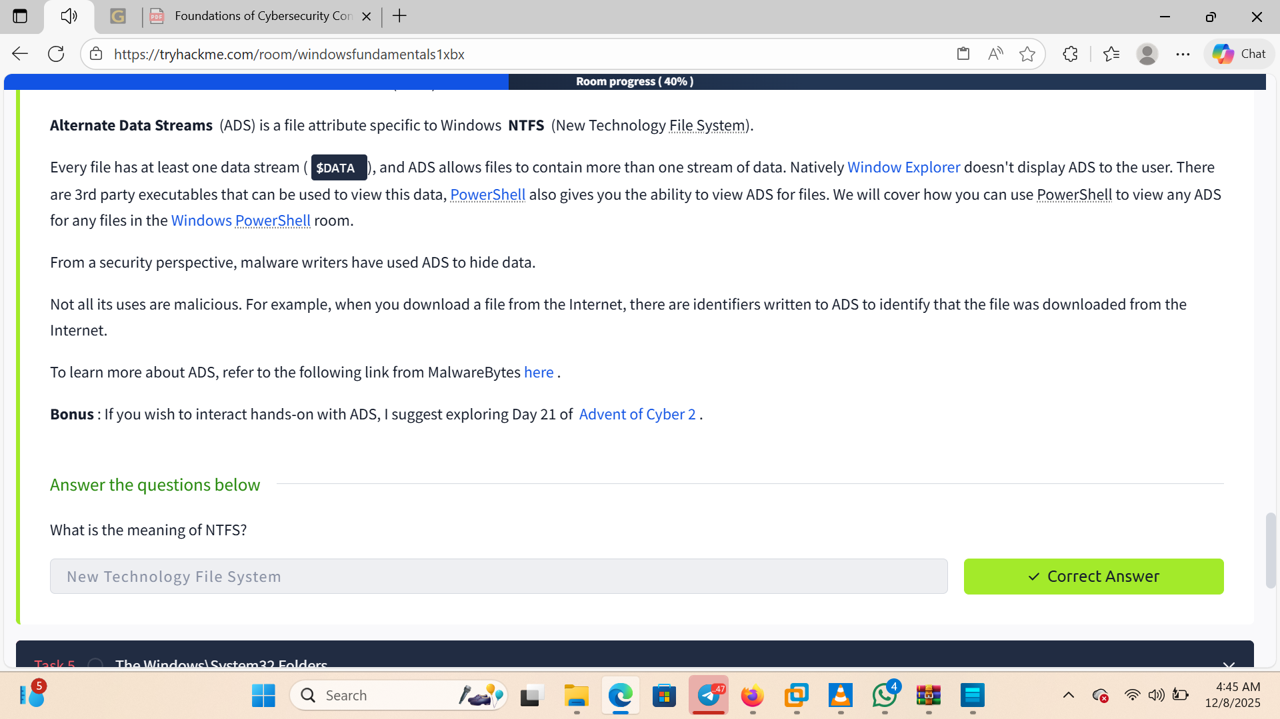

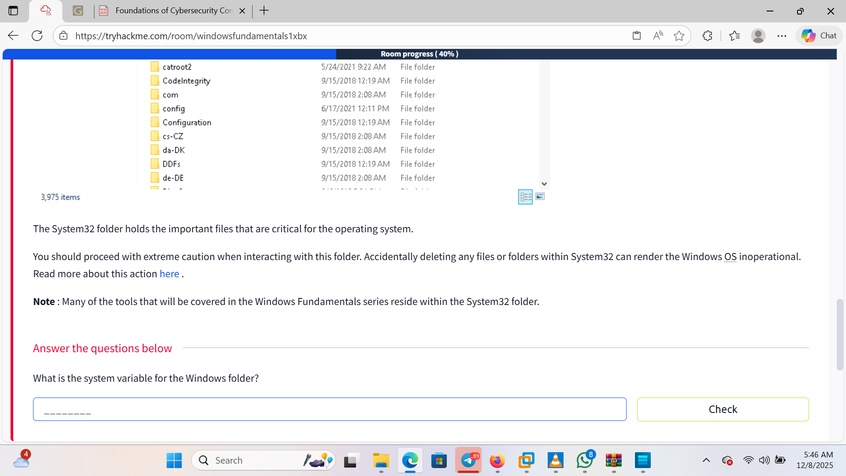

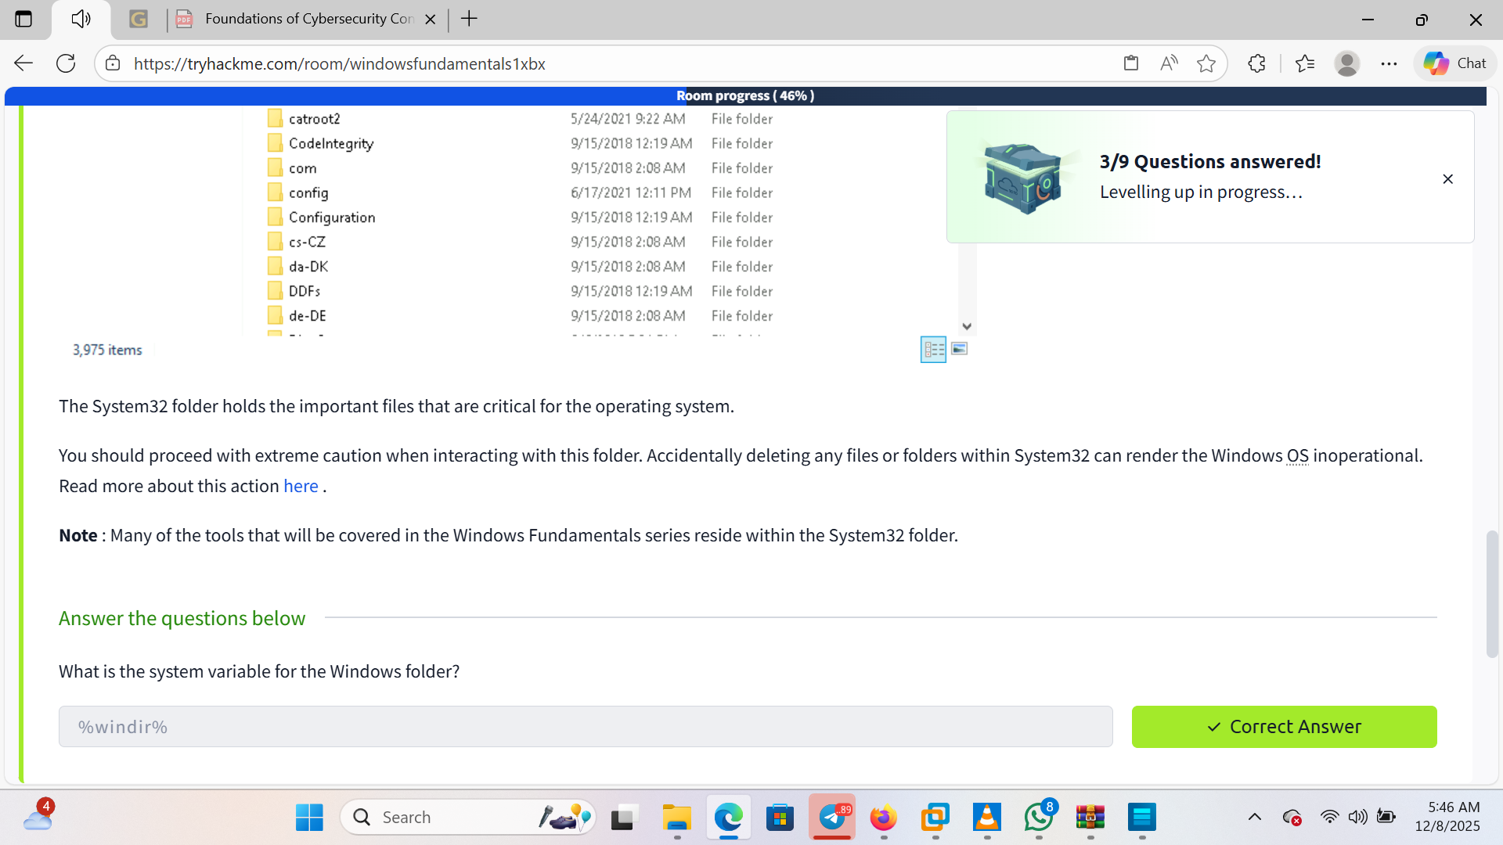

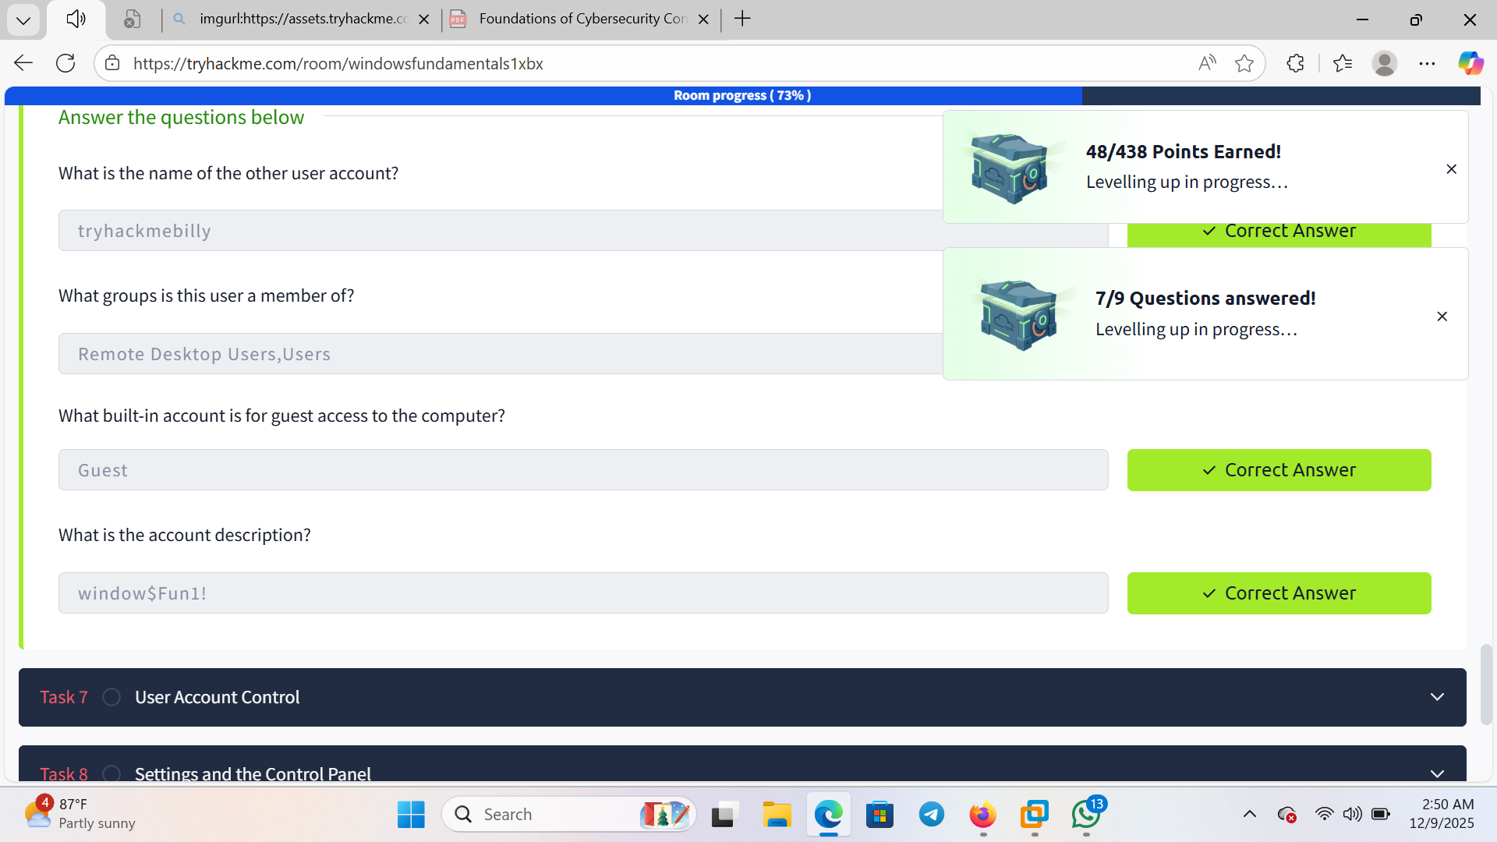

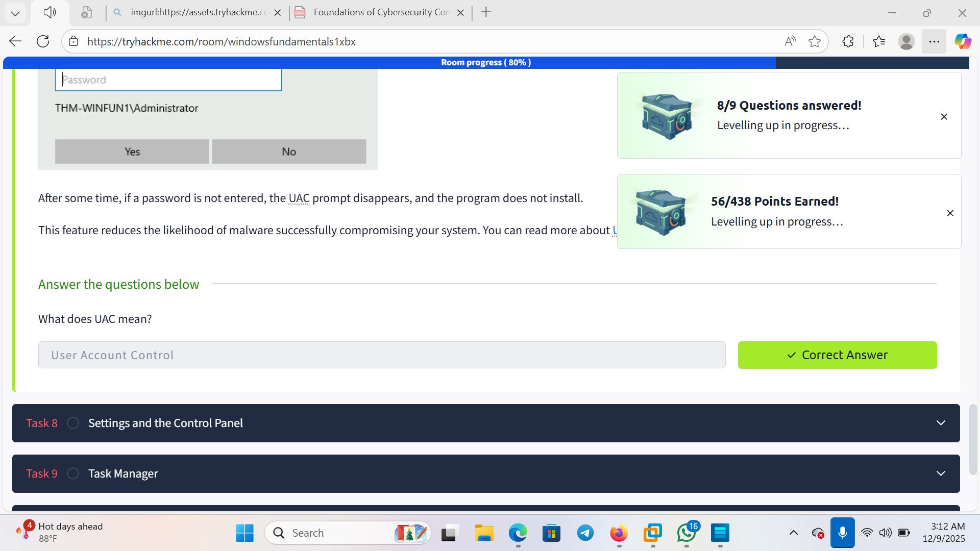

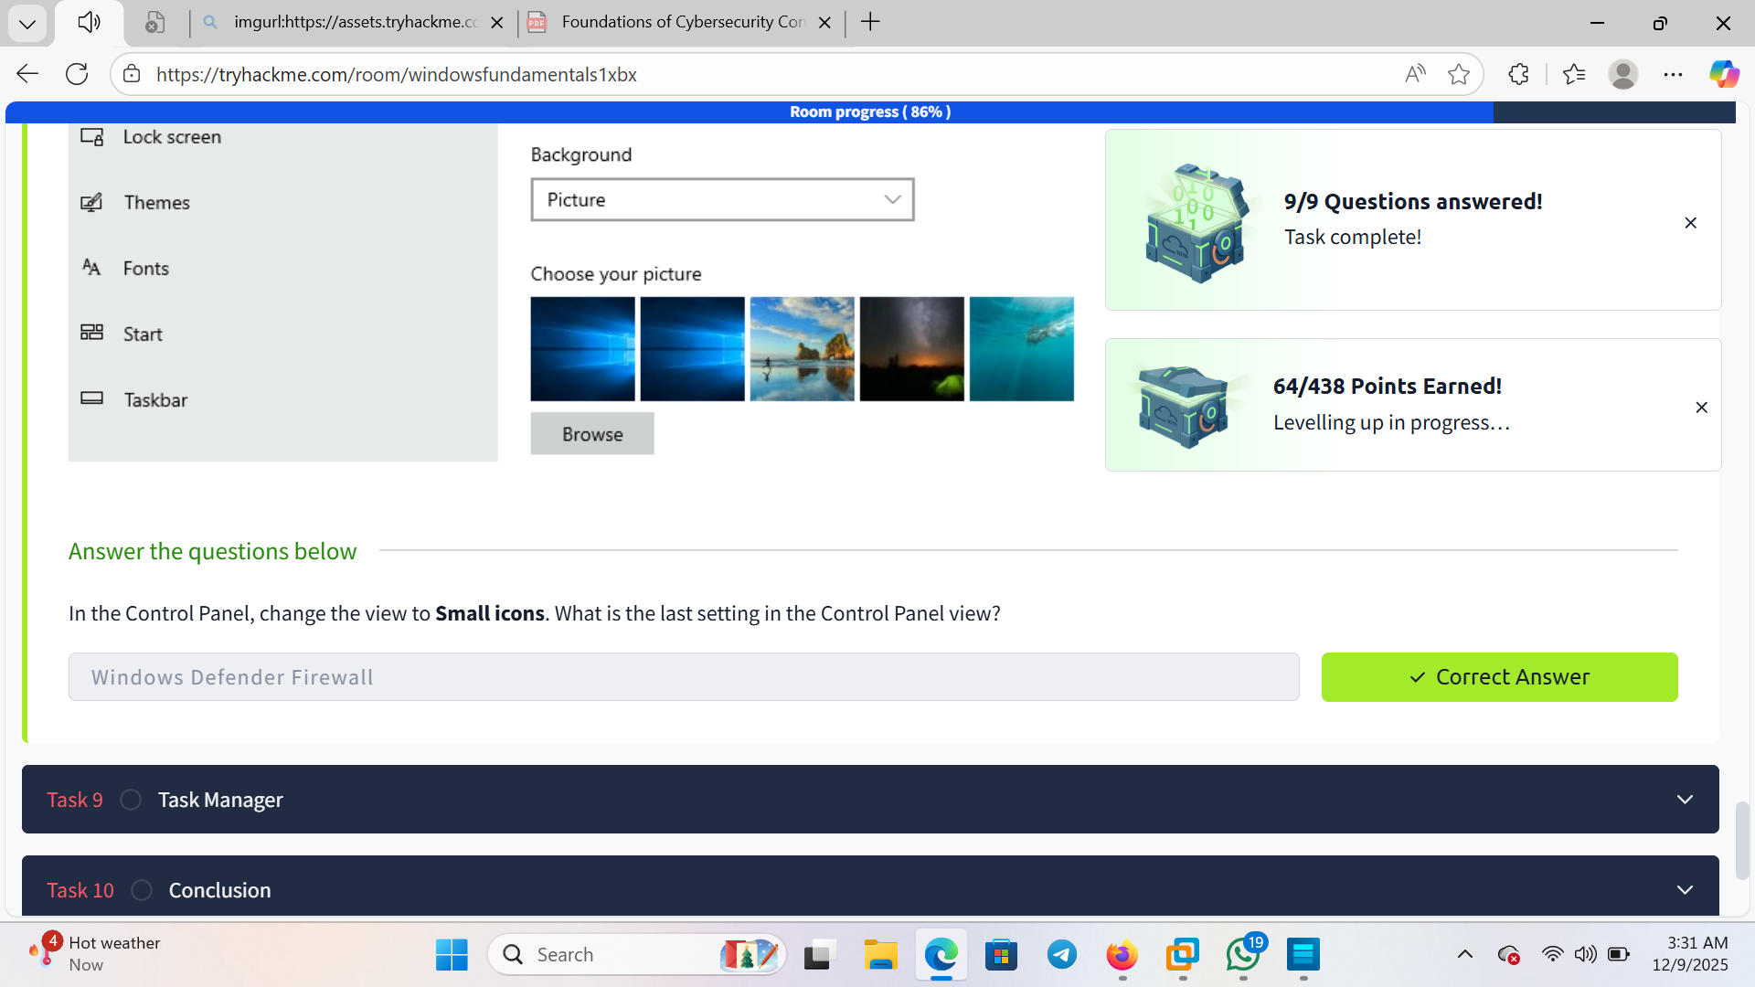

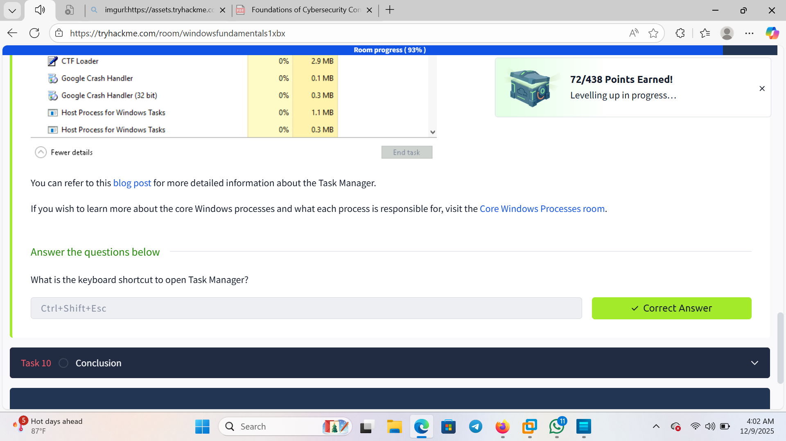

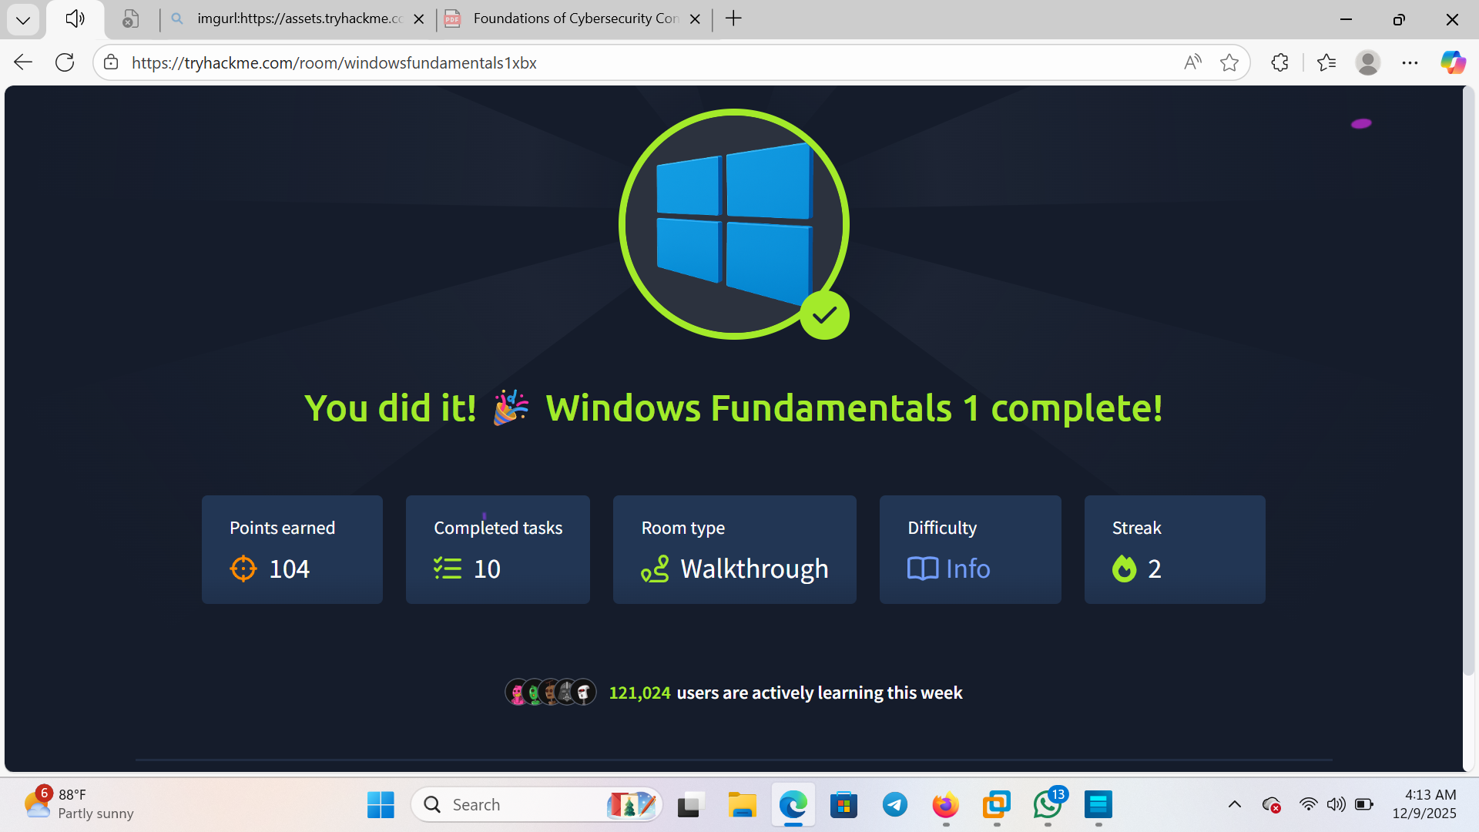

Windows fundamental 2

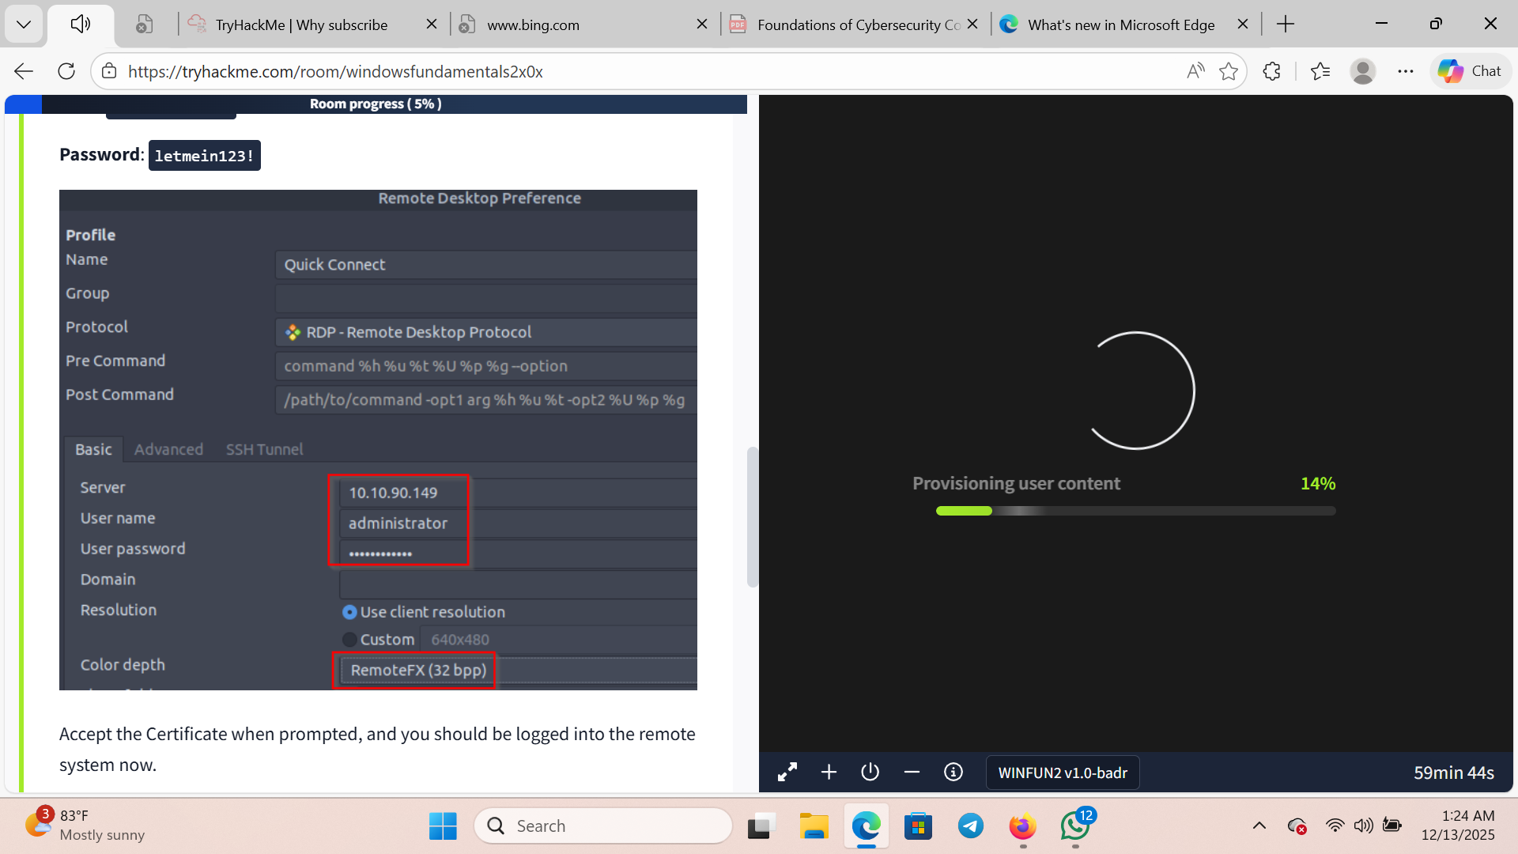

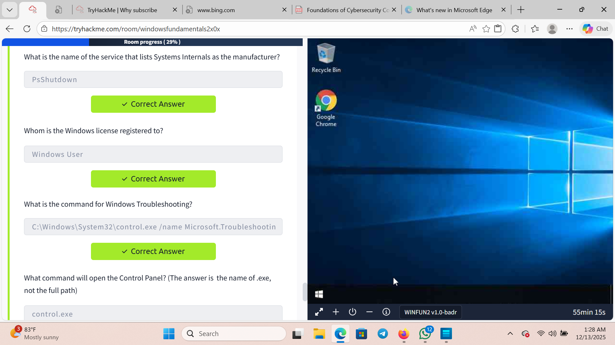

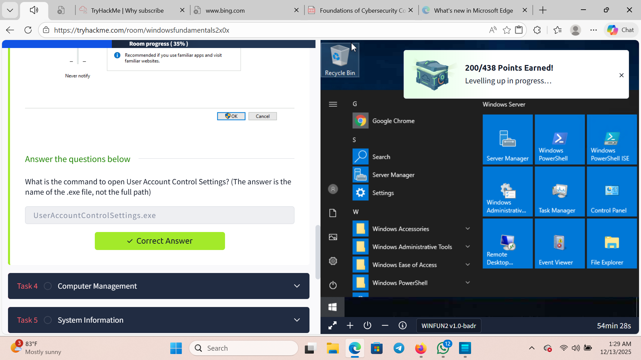

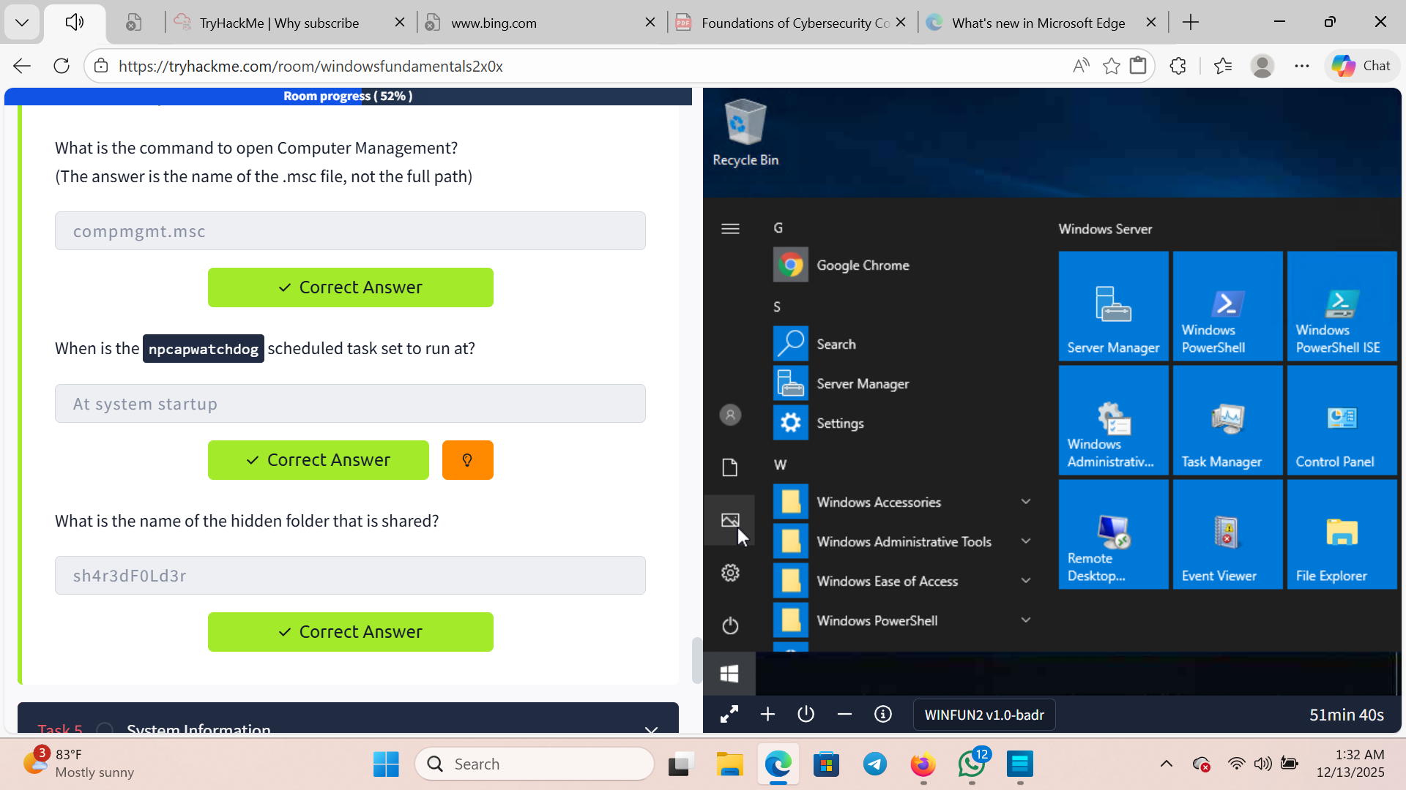

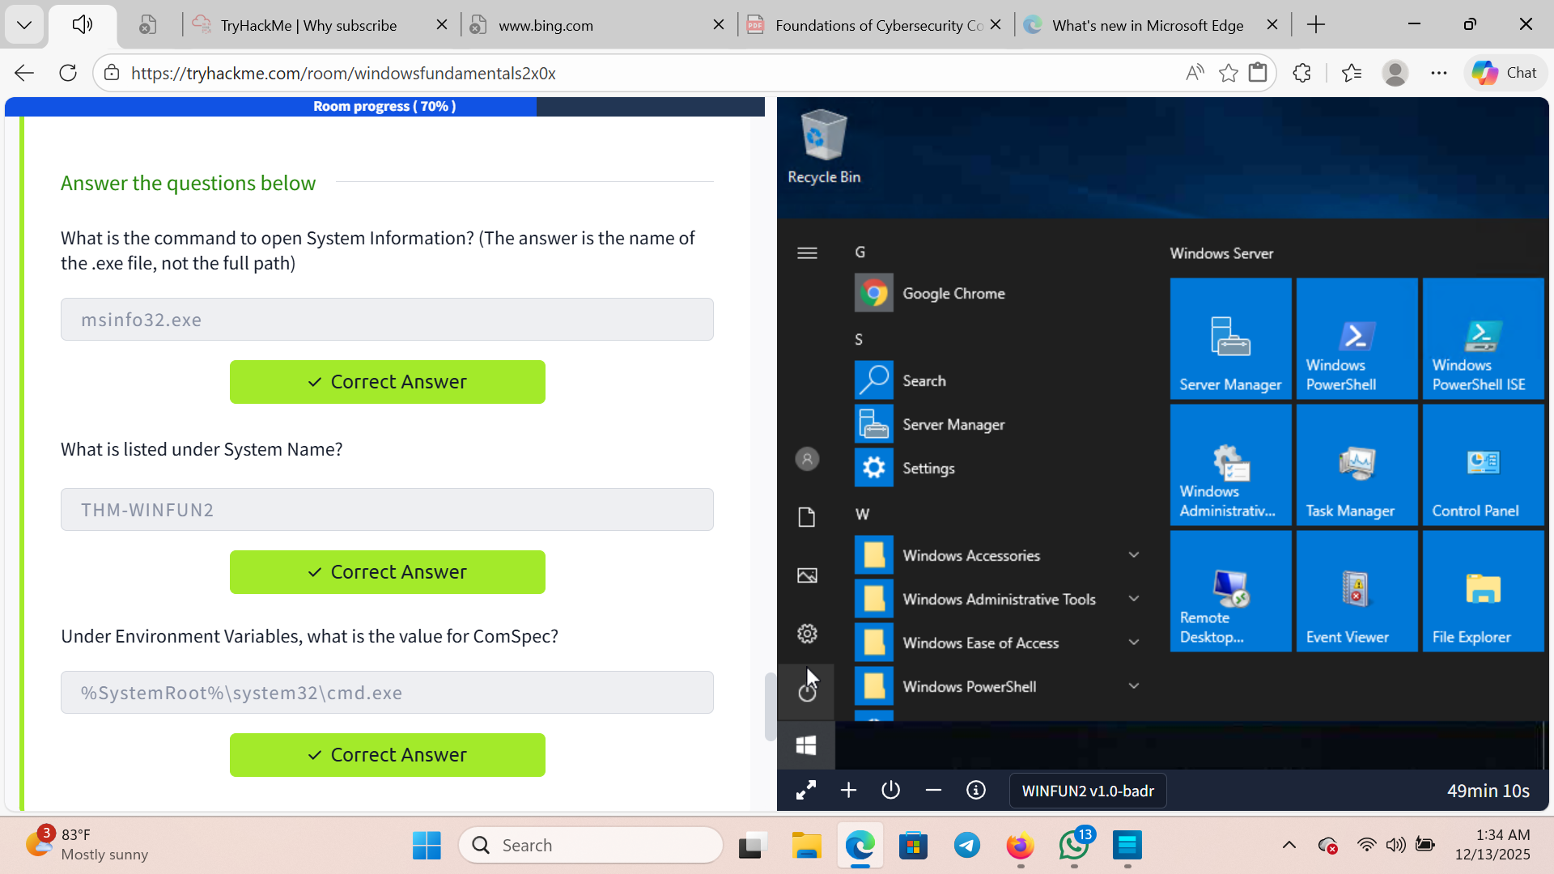

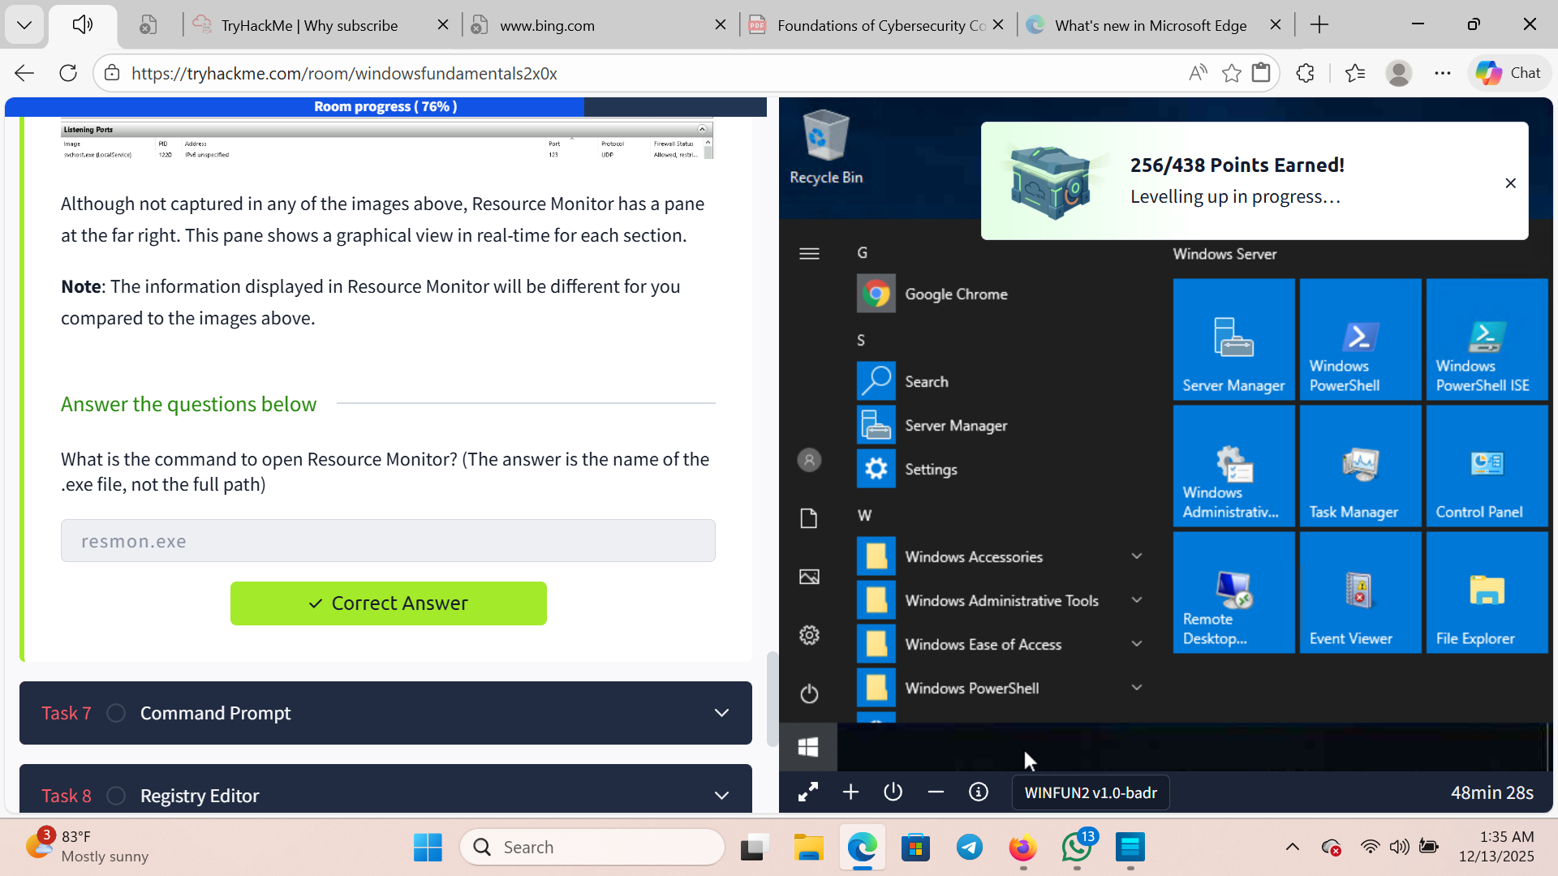

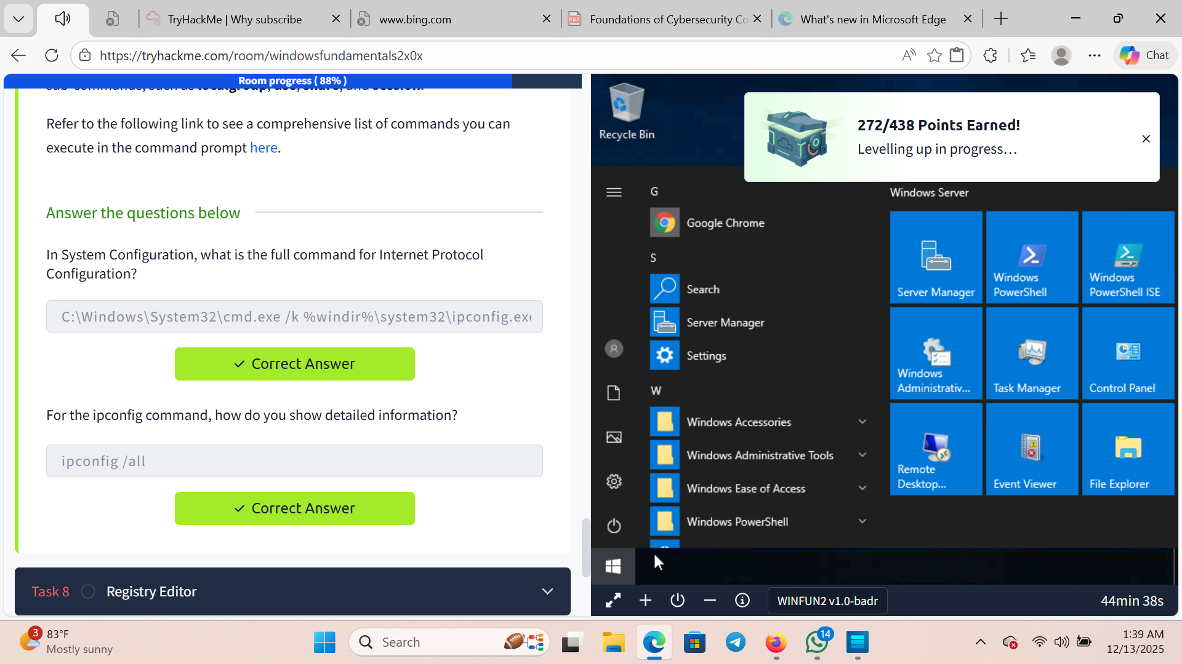

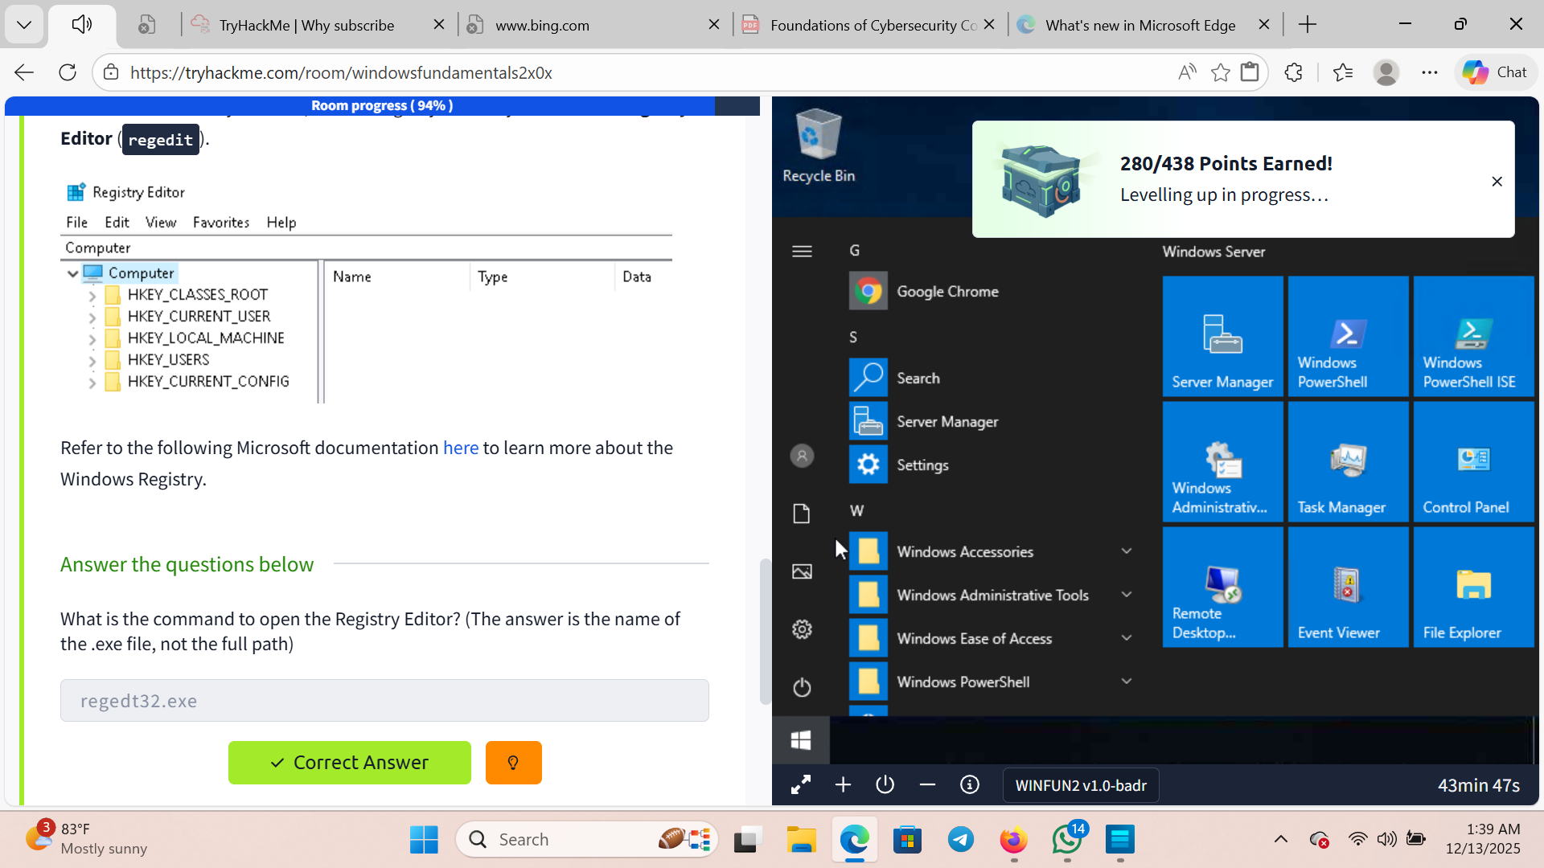

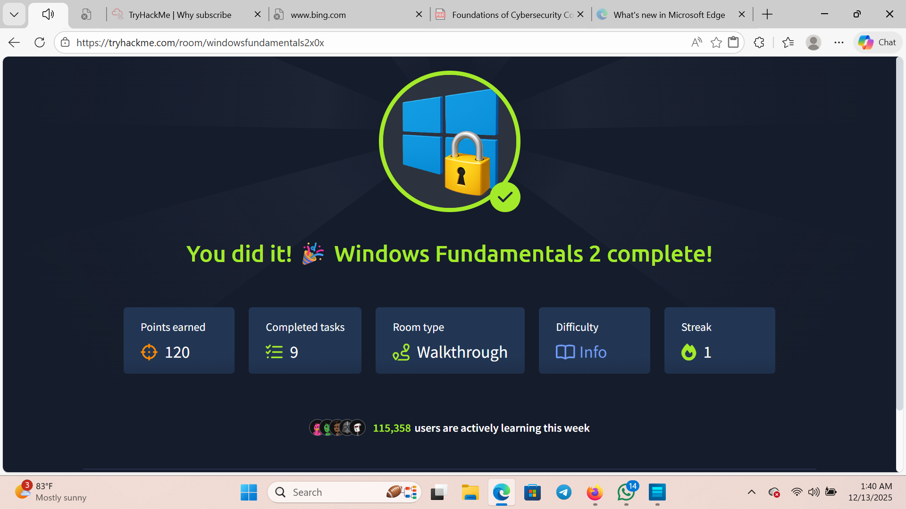

Windows fundamental 3

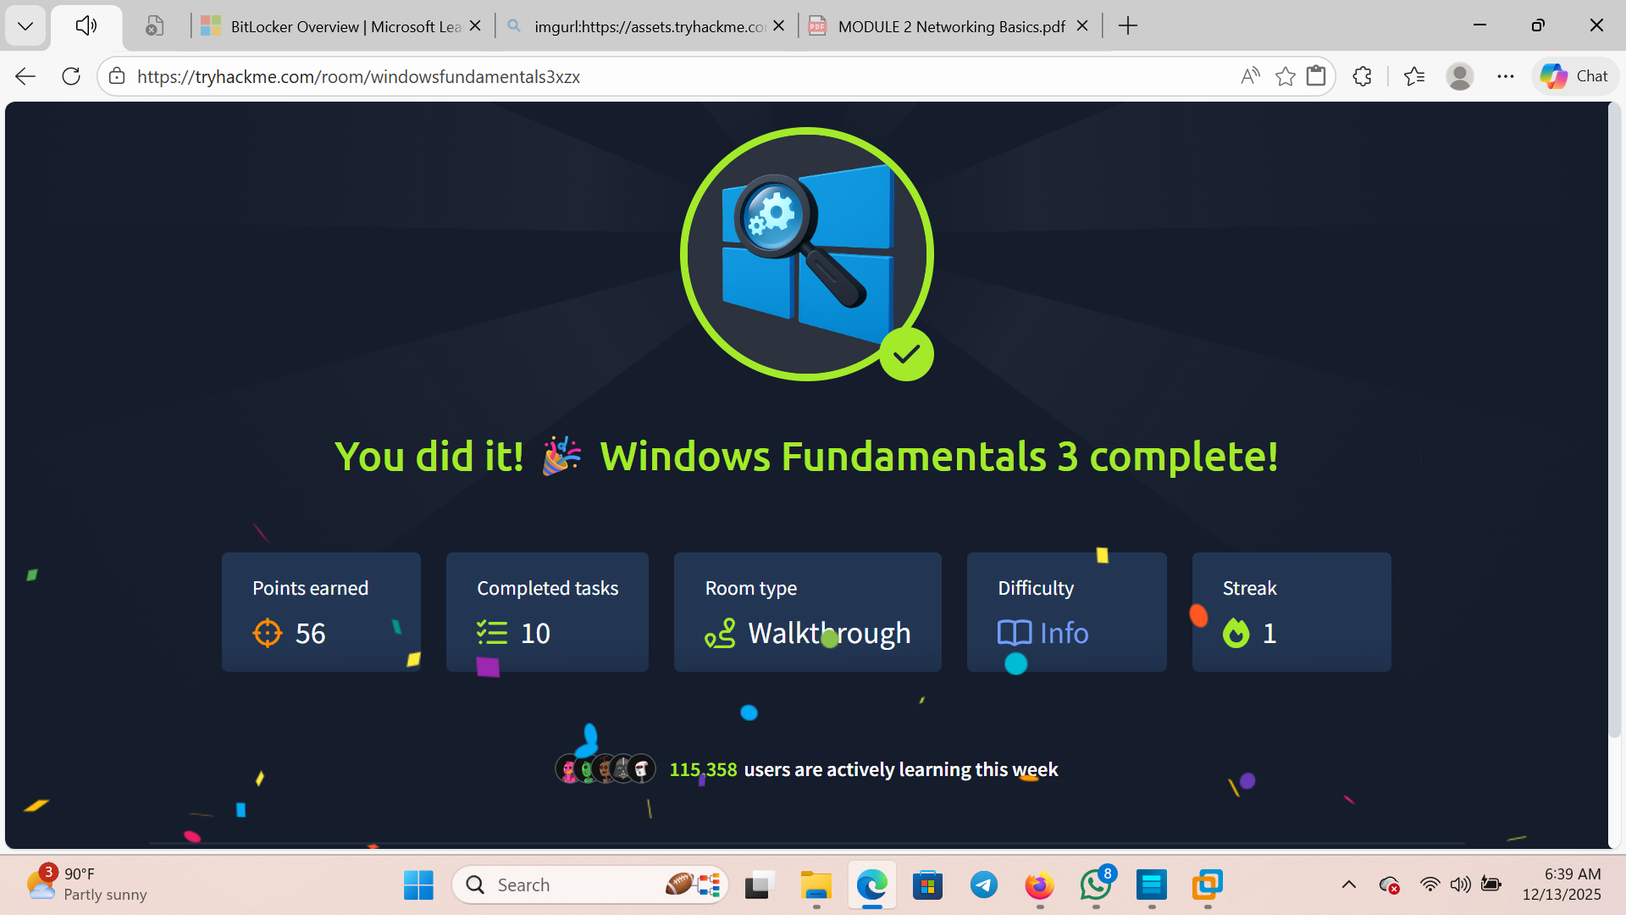

Linux fundamental 1

